Brian Sostek

Benjamin Miller

ENGCMP 0610

22 Sep 2020

Soundscape Reflection

When I first looked at the curriculum for Composing Digital Media and I saw that we would be creating a soundscape, I was puzzled because I had never heard of a soundscape. After a brief google search, my head filled up with ideas of what I could create. My first idea was capturing the sounds from my bedroom on a summer morning. Birds chirping, lawn mower. I originally thought that soundscapes typically did not include dialogue, or even a plot. It was my impression that it was a collection of sounds reminiscent of a specific place’s ambience.

This notion was quickly erased after listening to the examples on the class page. I realized that the possibilities of a soundscape were nearly infinite. So again, my brain flooded with potential soundscape ideas. I believe that the choice of what I was going to make was the most difficult part of the process. Once I completed my proposal, everything was smooth sailing.

But making the proposal was not a mundane task. I was between two ideas but I ended up going with the boardwalk soundscape. Once I ultimately decided to go with the boardwalk idea, I had to decide what each of my assets would be. After deciding at least what the ambience assets were going to be, I was ready to start working in Audacity.

I started making my soundscape during class. When I came up with the intro to my project, I thought of my previous trips to the boardwalk and what they were like. I knew I would have to come up with a story later on, but I didn’t think about that at the moment. The intro to my soundscape was a car pulling up to a parking lot, and the doors closing and opening.

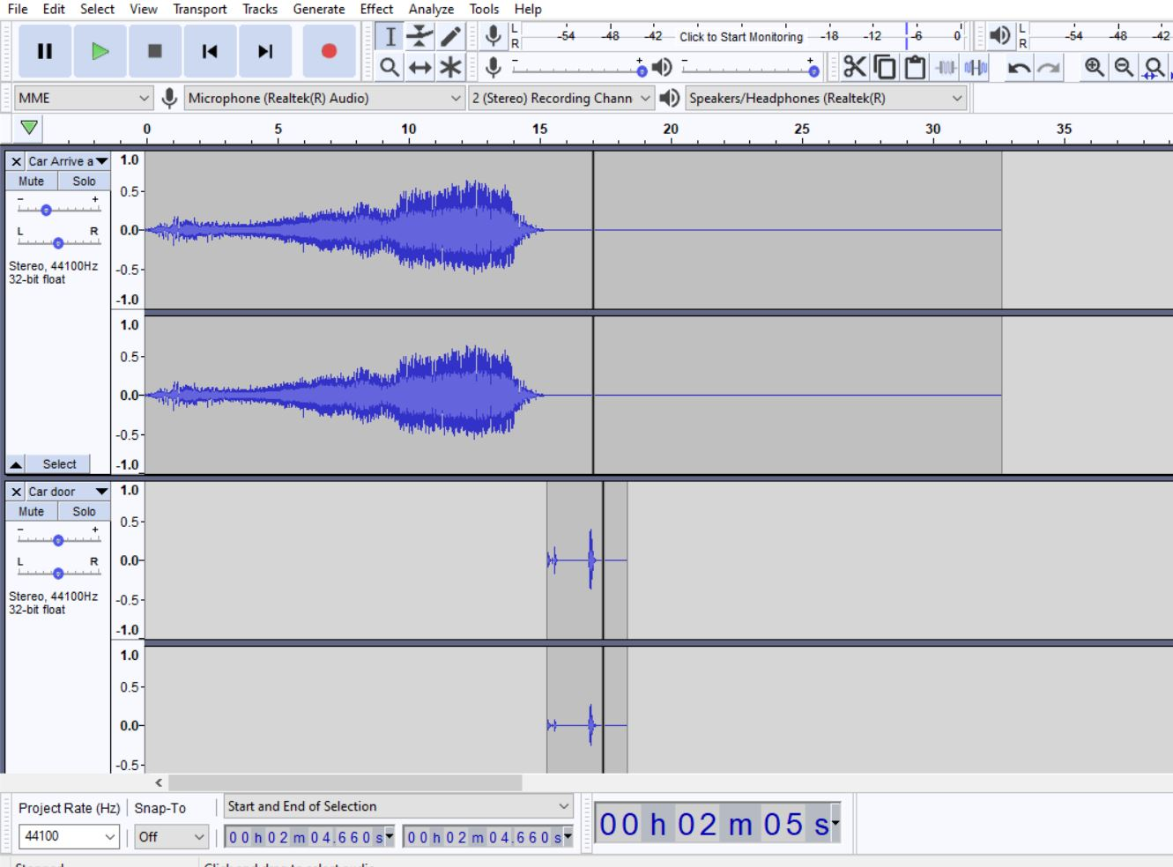

Immediately after the door opened, I thought, what is the first sound I would hear? Probably music coming from the boardwalk. I inserted my music in there, which originally was a dummy track I found on one of the creative common sites. I did not like the song, but it was just used for seeing how I was going to structure the ambience. I knew I could replace the song later. Once I found my correct song, I added a lengthy fade in to simulate the boardwalk approaching closer and closer as we walked toward it. While walking, I added a sunscreen sound effect from squeezing a bottle of sunscreen in my bathroom. The sound was not loud enough, so I improvised by making a bottle squirting sound with my mouth. It was a joke originally, but it made it to the final cut. I added boardwalk sounds, which happened to be from Ocean City, NJ which is the exact boardwalk I had in mind. Finally, I added wave sounds to complete the ambience.

After the ambience was set, all that was left was to add the dialogue and fix the sound levels and blend everything together. All the dialogue was original, and none of it was written down. I chose my roommate to be my supporting voice actor, and the main subject of the story. I wrote the story as I recorded the dialogue, but I thought about what the general plot would be. I found a time when we were both available to record.

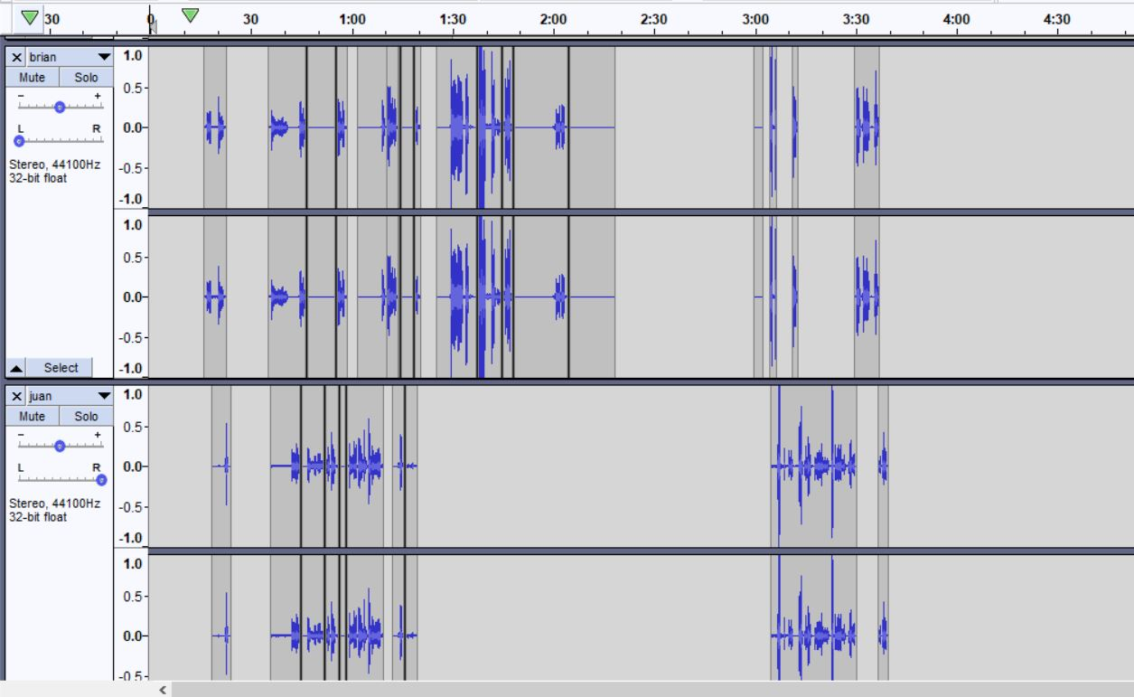 I panned my audio to the left and Juan’s (my roomate’s) to the right. This was where the majority of the dialogue happened. As you can see from the audio, you can almost tell the structure of the story. Juan and I are together, then he gets lost, and then I find him at the end. Once all the dialogue was recorded and mastered, I fixed the sound levels and added some interesting effects, such as fast-forwarding time to simulate me waiting for my friend.

I really enjoyed this project, because I used to make videos all the time with my friends, which is a very similar process. This just focuses more on specific details whereas making a movie is more plot based and affect based. And in a movie, it is easier to tell what is going on. I hope I get to do another soundscape in my time at Pitt or maybe for my job. I found it pretty relaxing and fun.